MAJOR – SEP

Name – Anjali Kuamri

Email – [anjalirajwar101@gmail.com](mailto:anjalirajwar101@gmail.com)

College Name – Bit sindri

**Cyber Security Major Project**

**4. Perform SQL injection Manually on http://testphp.vulnweb.com Write a report along with**

**screenshots and mention preventive steps to avoid SQL injections**

SQL injection is a technique used to exploit user data through web page inputs by injecting SQL commands as statements. Basically, these statements can be used to manipulate the application’s web server by malicious users.

Login command:-

1’or’1’=’1

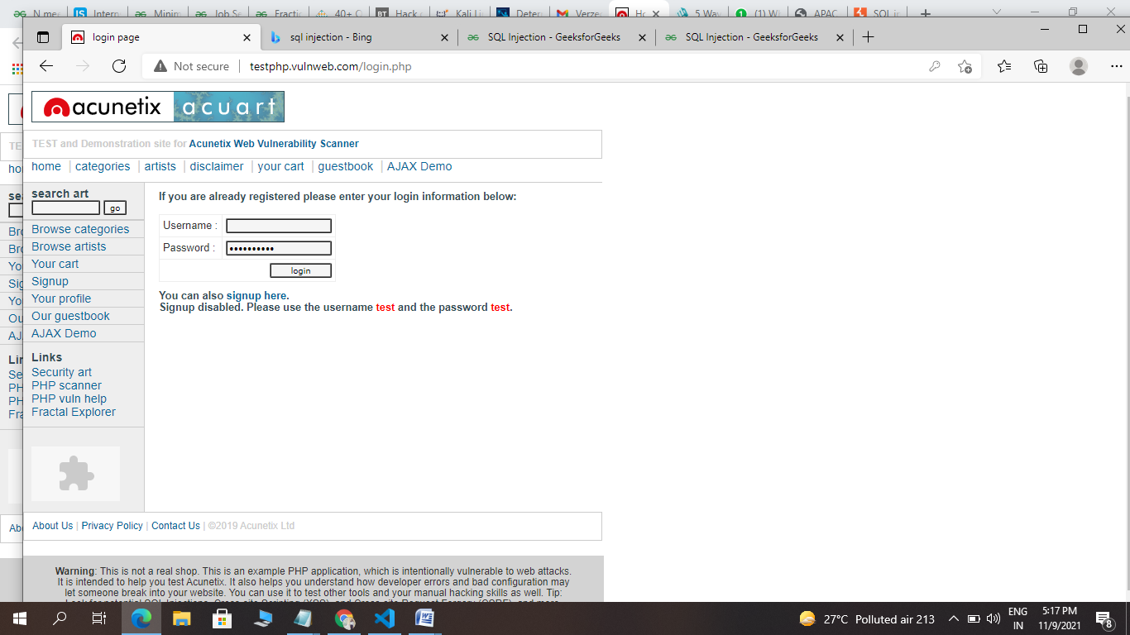

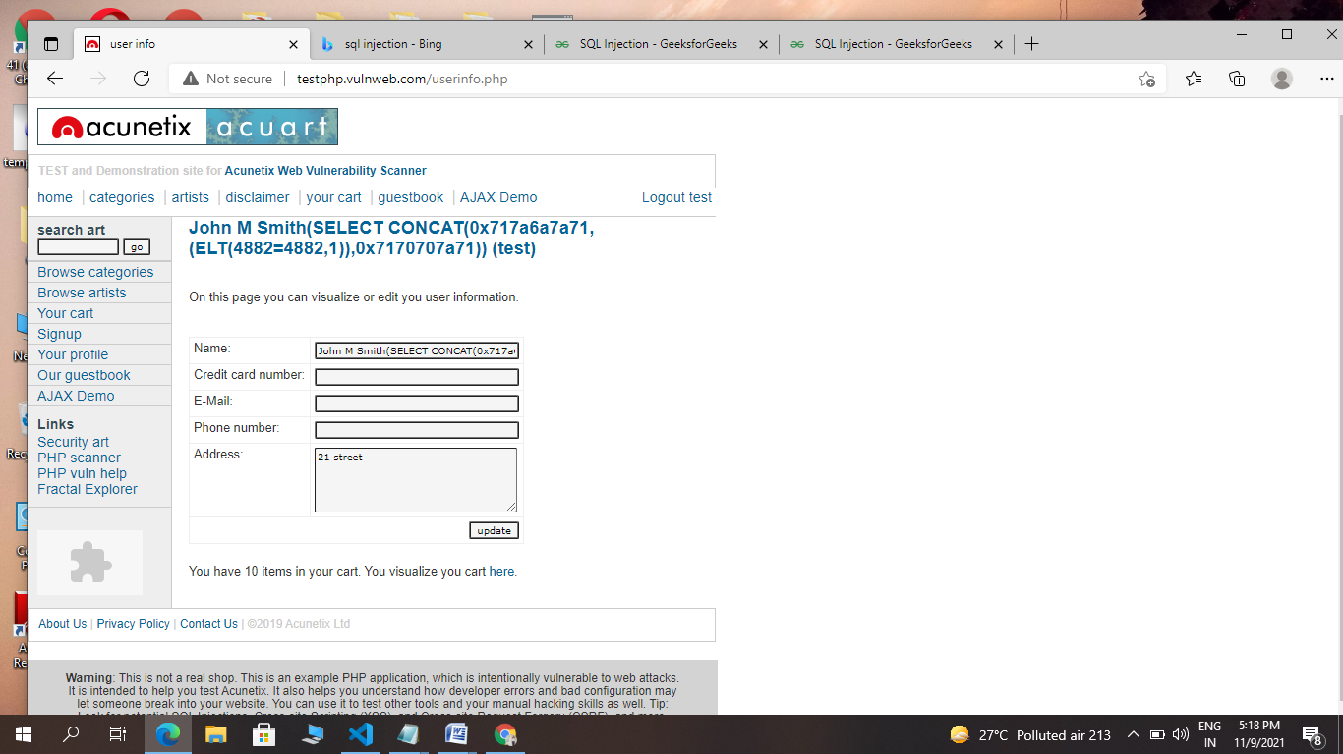

## Are you vulnerable to a SQL injection attack?

### Self-Imposed Attacks & Detection Types

### Testing For SQL Injection Vulnerabilities

### Utilizing An SQLi Detection Tool

[BBQSQL](https://tools.kali.org/vulnerability-analysis/bbqsql#:~:text=BBQSQL%20is%20a%20blind%20SQL,to%20trigger%20SQL%20injection%20findings.)

* [Blind-SQL-Bitshifting](https://github.com/awnumar/blind-sql-bitshifting)
* [Blisqy](https://github.com/JohnTroony/Blisqy)
* [Damn Small SQLi Scanner](https://github.com/stamparm/DSSS) (DSSS)
* [explo](https://github.com/telekom-security/explo)
* [Leviathan](https://github.com/utkusen/leviathan)
* [NoSQLMap](https://github.com/codingo/NoSQLMap)
* [Tyrant-SQL](https://github.com/aron-bordin/Tyrant-SQL)
* [Whitewidow](https://github.com/WhitewidowScanner/whitewidow)

**Steps to prevent SQL injection attacks**

### 1. Validate User Inputs

### 2. Sanitize Data By Limiting Special Characters

### 3. Enforce Prepared Statements And Parameterization

### 4. Use Stored Procedures In The Database

### 5. Actively Manage Patches And Updates

### 6. Raise Virtual Or Physical Firewalls

### 7. Harden Your OS And Applications

### 8. Reduce Your Attack Surface

### 9. Establish Appropriate Privileges And Strict Access

### 10. Limit Read-Access

### 11. Encryption: Keep Your Secrets Secret

### 12. Deny Extended URLs

### 13. Don’t Divulge More Than Necessary In Error Messages

### 14. No Shared Databases Or User Accounts

### 15. Enforce Best Practices For Account And Password Policies

### 16. Continuous Monitoring Of SQL Statements

### 17. Perform Regular Auditing And Penetration Testing

### 18. Code Development & Buying Better Software

## Stopping SQL injections recap

* Privileged Access Management (PAM)
* [Penetration Testing](https://www.esecurityplanet.com/products/best-penetration-testing/)
* [Security Information and Event Management](https://www.esecurityplanet.com/products/siem-tools/) (SIEM)
* [Next-Generation Firewall](https://www.esecurityplanet.com/products/top-ngfw/) (NGFW)
* [Network Access Control](https://www.esecurityplanet.com/products/networks/-access-control-solutions/) (NAC)
* [Intrusion Detection and Prevention](https://www.esecurityplanet.com/products/intrusion-detection-and-prevention-systems/) (IDPS)
* [Threat Intelligence](https://www.esecurityplanet.com/products/threat-intelligence-platforms/)
* [User and Entity Behavior Analytics](https://www.esecurityplanet.com/products/best-user-and-entity-behavior-analytics-ueba-tools/) (UEBA)

**Thank You…**